
RESTful SDK

Last Modified: 10/03/2011

Author: Prasad Konka
Client: National Cancer Institute - Center for Bioinformatics,
National Institutes of Health,
US Department of Health and Human Services

Document History

Document Location
The most current version of this document is located in CVS under security/docs.

Revision History
Version Number | Revision Date | Author | Summary of Changes
1.0 | 10/03/2011 | Prasad Konka | Draft Version

Review
Name | Team/Role | Version | Date Reviewed | Reviewer Comments

Related Documents
More information can be found in the following related CSM documents:

Document Name

Table of Contents

Contents
1. Purpose 4
2. Introduction 4
2.1 SDK REST-like Service 5
3. RESTful Webservices 9
3.1 JAX-RS (JSR-311) 9
3.2 Architecture 10
3.3 JAX-RS Implementations 11
3.4 Comparison 12
4. RESTful SDK 15
5. References 16

Purpose
The purpose of this document is to look at existing SDK REST-like implementation and its limitations. This document looks at standards based approach to enhance existing REST-like implementation to be RESTful implementation.

Introduction
The National Cancer Institute (NCI) Center for Biomedical Informatics and Information Technology (CBIIT) provides biomedical informatics support and integration capabilities to the cancer research community. CBIIT has created the caCORE Software Development Kit or caCORE SDK, a data management framework designed for researchers who need to be able to navigate through a large number of data sources. caCORE SDK is CBIIT’s platform for data management and semantic integration, built using formal techniques from the software engineering and computer science communities.

By providing a common data management framework, caCORE SDK helps streamline the informatics development throughout academic, government and private research labs and clinics. A caCORE SDK generated system is built on the principles of Model Driven Architecture (MDA) and specifically Model Driven Development (MDD) and n-tier architecture and consistent API. Model Driven Architecture (MDA) and MDD is a software development practice that uses a structured modeling language to describe the requirements, objects, and interactions of a data system prior to its construction. The use of MDA and n-tier architecture, both standard software engineering practices, allows for easy access to data, particularly by other applications.

Users of the caCORE SDK benefit in numerous ways. The primary benefits of using the caCORE SDK includes:
- Consistent UML representation of the data – Users of the caCORE SDK are required to represent their data in UML format. As a user of the SDK, the user is likely to maintain their UML model throughout the life cycle of the application. The same UML model can be used to quickly learn about the organization of the data at various levels in the application.
- Rapid data service generation – The SDK can generate caBIG silver-level compatible APIs quickly from the UML model. Once the UML model and the database are ready, the data service can be generated in a matter of hours. Manually building the application from the ground up can take several months to achieve the same functionality.
- Uniform way to access data – SDK-generated systems provide uniform access to the data stores. Other applications developed using the caCORE SDK have similar mechanisms to retrieve the data. Thus common data representation allows multiple applications to share data.
- Query using information model – SDK-generated systems allow queries to be written in various ways including using Query-By-Example. Since the query is independent of the system’s implementation, changes in the runtime systems do not affect the client application.
- Integration with caGrid – SDK-generated systems can be easily integrated with caGrid using the caGrid Introduce Toolkit. Developing caGrid-compatible data services without using caCORE SDK can result in error-prone and lengthy processes.
- Integrated Security with CSM – SDK generated system can be made secured with CSM. In addition to authentication and authorization configuration, CSM provides, class level, instance level, and attribute level security out of the box.

SDK REST-like Service
The Representational State Transfer (REST) interface provided by the caCORE SDK is a simple URL interface that transmits domain-specific data over HTTP without an additional messaging layer, such as SOAP, or session tracking via HTTP cookies.
This XML-JSON-HTTP interface can be accessed in two ways: from a web browser or from a thin client application that can fetch data in XML or JavaScript Object Notation (JSON) format from the server using the REST-like syntax
The URL used by the REST interface adheres to the following pattern:
http://<server_name><server_port>/<project_name>/ <REST_type>?query=<target>&<criteria>[&rolename=<rolename>]
The following table describes each of the parameters of the REST URL:
Parameter | Description
server_name | A string identifying the server or host name. For example: localhost or 127.0.0.1.
server_port | A string identifying the port number to which the caCORE SDK server is listening. For example: 80 or 8080
Project_name | A string identifying the project name used for building and deploying the caCORE SDK application. For example: myproject or example.
REST_type | Either GetXML for XML output or GetJSON for JavaScript Object Notation output
Target | A string identifying the qualified or non-qualified query target/result class name.  For example: gov.nih.nci.cacoresdk.domain.inheritance.childwithassociation.Bank
Criteria | A string identifying the qualified or non-qualified criteria class name to be used as a filter/constraint on the result set.  For example: The caCORE SDK sample model Credit class has an association to the Bank class via its issuingBank attribute. If desired, the value of the id attribute of the criteria class instance can also be supplied in order to further constrain the result set. The pattern for such a criteria string is:  <criteria_class_name>[@<attribute_name>=<attribute_value>]  Thus the criteria entry of Credit[@id=3] indicates that only target result class instances that are associated to the Credit record with an id value of 3 are to be returned.
Rolename | The name of the attribute within the criteria class that identifies the association to be traversed when retrieving the target result class(es). One example is the issuingBank attribute of the Credit class found within the caCORE SDK sample model.  The rolename property must be specified whenever the Criteria class has two or more attributes representing associations to the same target/result class type.  For example: The Child class within the caCORE SDK sample model contains two attributes: motherand father. Both represent instances of the Parent class. In this scenario, specifying a value of rolename=mother or rolename=father within the REST URL would ensure that the correct Parent instance is returned.

The following table provides some example URLs taken from the caCORE SDK sample model:
Sample XML REST URL | http://localhost:8080/example/GetXML?query=Bank&Credit\[@id=3\]&roleName=issuingBank
Sample JSON REST URL | http://localhost:8080/example/GetJSON?query=Bank&Credit\[@id=3\]&roleName=issuingBank

Following is an example of output XML returned by SDK REST-like service.
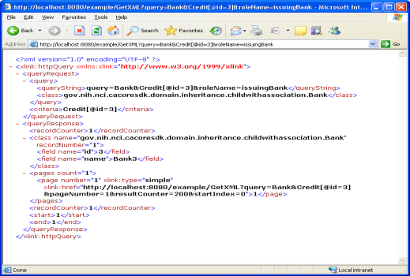

More information on SDK REST-like interface can be found at:
https://wiki.nci.nih.gov/display/caCORE/8.2+-+XML-JSON-HTTP+Interface+for+caCORE+SDK+4.4

The caCORE SDK generated runtime system's infrastructure exhibits an n-tiered architecture with client interfaces, server components, backend objects, data sources, and additional backend systems. XML-JSON-HTTP Interface implements REST-like capability by serving requests over HTTP and returning formatted results as HTML, XML or JSON.
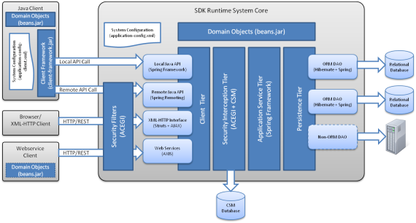
SDK adopted its own implementation of REST style through a custom Servlet that takes request with predefined query parameters and format. This Servlet process query requests, validates query format and its parameters, determine output format, query results using ApplicationService and convert results into desired format.

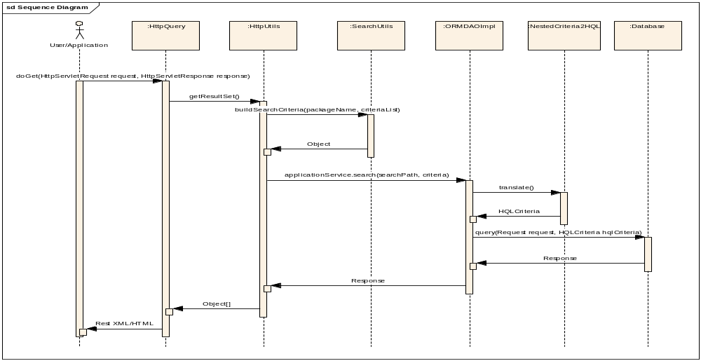

Following diagrams represents high level flow of request and response in the SDK REST-like implementation.

RESTful Webservices
RESTful Web services are services that are built to work best on the Web.
Representational State Transfer (REST) is an architectural style that specifies constraints, such as the uniform interface, that if applied to a Web service induce desirable properties, such as performance, scalability and modifiability, that enable services to work best on the Web.
In the REST architectural style, data and functionality are considered resources, and these resources are accessed using Uniform Resource Identifiers (URIs), typically links on the web. The resources are acted upon by using a set of simple, well-defined operations. The REST architectural style constraints an architecture to a client-server architecture, and is designed to use a stateless communication protocol, typically HTTP. In the REST architecture style, clients and servers exchange representations of resources using a standardized interface and protocol. These principles encourages RESTful applications to be simple, lightweight, and have high performance.
To find out more about REST, try these sources for more information:
- Fielding Dissertation: Chapter 5: Representational State Transfer (REST), at http://www.ics.uci.edu/~fielding/pubs/dissertation/rest_arch_style.htm
- Wikipedia article on Representational State Transfer (REST), at http://en.wikipedia.org/wiki/RESTful

JAX-RS (JSR-311)
This speciﬁcation deﬁnes a set of Java APIs for the development of Web services built according to the Representational State Transfer[1] (REST) architectural style. Following are the goals of JAX-RS specification:

POJO-based: The API provides a set of annotations and associated classes/interfaces that may be used with POJOs in order to expose them as Web resources. The speciﬁcation deﬁnes object lifecycle and scope.

HTTP-centric: The speciﬁcation assumes HTTP is the underlying network protocol and provides a clear mapping between HTTP and URI elements and the corresponding API classes and annotations. The API provides high level support for common HTTP usage patterns and will be sufficiently ﬂexible to support a variety of HTTP applications including WebDAV and the Atom Publishing Protocol.

Format independence: The API is applicable to a wide variety of HTTP entity body content types. It provides the necessary pluggability to allow additional types to be added by an application in a standard manner.

Container independence: Artifacts using the API are deployable in a variety of Web-tier containers. The speciﬁcation deﬁnes how artifacts are deployed in a Servlet container and as a JAX-WS Provider.

Inclusion in Java EE: The speciﬁcation deﬁnes the environment for a Web resource class hosted in a Java EE container and specifies how to use Java EE features and components within a Web resource class.

Architecture
In a REST based architecture everything is a resource. A resource is accessed via a common interface based on the HTTP standard methods. In a REST architecture you typically have a REST server which provides access to the resources and a REST client which accesses and modify the REST resources. Every resource should support the HTTP common operations. Resources are identified by global ID's (which are typically URIs).
REST allows that resources have different representations, e.g. text, xml, json etc. The rest client can ask for specific representation via the HTTP protocol (Content Negotiation).
The HTTP standards methods which are typical used in REST are PUT, GET, POST, DELETE.
- GET defines a reading access of the resource without side-effects. The resource is never changed via a GET request, e.g. the request has no side effects (idempotent).
- PUT creates a new resource, must also be idempotent.
- DELETE removes the resources. The operations are idempotent, they can get repeated without leading to different results.
- POST updates an existing resource or creates a new resource.
A RESTful webservice is based on the HTTP methods and the concept of REST. It typically defines the base URI for the services, the MIME-types its supports (XML, Text, JSON, user-defined,..) and the set of operations (POST, GET, PUT, DELETE) which are supported. JAX-RS uses annotations to define the REST relevance of classes.

JAX-RS Implementations
JAX-RS has been gaining traction in past couple of years and there are several production grade reference implementations available. Following are some of the implementations:

Restlet:
Restlet is a comprehensive yet lightweight RESTful web framework for Java that lets you embrace the architecture style of the Web (REST) and benefit from its simplicity and scalability. It supports all REST concepts (Resource, Representation, Connector, Component, etc.) and is suitable for both client and server Web applications. It supports major Web standards like HTTP, SMTP, XML, JSON, WADL, and Atom. Many extensions are also available to integrate with Servlet, Spring, Jetty, Grizzly, Simple, JAXB, JAX-RS, JiBX, Velocity, FreeMarker, XStream, Jackson, SLF4J, ROME, Netty and many more.

RestEasy:
RESTEasy is a JBoss project that provides various frameworks to help you build RESTful Web Services and RESTful Java applications. It is a fully certified and portable implementation of the JAX-RS specification. RESTEasy can run in any Servlet container, but tighter integration with the JBoss Application Server is also available to make the user experience nicer in that environment. While JAX-RS is only a server-side specification, RESTEasy has innovated to bring JAX-RS to the client through the RESTEasy JAX-RS Client Framework.

Jersey (Reference Implementation):
Jersey is the open source, production quality, JAX-RS (JSR 311) Reference Implementation for building RESTful Web services. Jersey implements support for the annotations defined in JSR-311, making it easy for developers to build RESTful web services with Java and the Java JVM. Jersey provides an API so that developers may extend Jersey to suit their needs.

CXF:
CXF has an implementation of JAX-RS 1.1 and JAX-RS 1.0 (JSR-311): Java API for RESTful Web Services. This provides a more standard way to build RESTful services in JAVA. CXF JAX-RS supports WADL. CXF JAX-RS service endpoints can be listed in the service listings page and users can check the WADL documents. JAX-RS services can be configured programmatically from Spring or using CXFNonSpringJAXRSServlet.

Comparison
As JAX-RS gaining popularity and maturity, there are several implementations available as mentioned above. Though each of these implementations follows JAX-RS specification, following sections is to compare these implementations to see how they fit within current and future direction of SDK. The comparison is mainly focused Jersey and CXF based on following categories.
- Maturity of the product
- Server-side Integration
- Java Client API
- Configurability
- Security

Maturity of the product:
Jersey is the open source, production quality, JAX-RS (JSR 311) Reference Implementation for building RESTful Web services. Jersey provides an API so that developers may extend Jersey to suit their needs. Jersey 1.9 implements JAX-RS 1.1. There are number of projects and products using Jersey in production currently.

Apache CXF is an open source services framework. CXF helps building and developing services using frontend programming APIs, like JAX-WS and JAX-RS. CXF supports a variety of web service standards including SOAP, the WS-I Basic Profile, WSDL, WS-Addressing, WS-Policy, WS-ReliableMessaging, WS-Security, WS-SecurityPolicy, WS-SecureConverstation, and WS-Trust (partial).

Server-side Integration:
Jersey provides additional value beyond the JAX-RS API. Jersey provides its own APIs that support Atom's XML format, MIME Multipart message format, JavaScript Object Notation (JSON), Web Application Description Language (WADL), as well as Spring framework integration.

CXF supports Multiple Transports, Protocol Bindings, Data Bindings, and Formats. Its flexible deployment supports deploying services in Jetty, Tomcat or Spring based containers, in JBI containers like ServiceMix, OpenESB or petals, in Java EE application services like Apache Geronimo, JOnAS, Redhat JBoss, OC4J, Oracle WebLogic, and IBM WebSphere. CXF supports a variety of "frontend" programming models. CXF is designed to be intuitive and easy to use. There are simple APIs to quickly build code-first services, Maven plug-ins to make tooling integration easy, JAX-WS API support, Spring 2.x XML support to make configuration a snap, and much more.

Java Client API:
The Jersey client API is a high-level Java based API for interoperating with RESTful Web services. It makes it very easy to interoperate with RESTful Web services and enables a developer to concisely and efficiently implement a reusable client-side solution that leverages existing and well established client-side HTTP implementations. The Jersey client API can be utilized to interoperate with any RESTful Web service, implemented using one of many frameworks, and is not restricted to services implemented using JAX-RS. Jersey Client API is HTTP centric and its support to proxy based client API is in experimental state. All the Java types for representations supported by the Jersey server side for requests and responses are also supported on the client side. This includes the standard Java types as specified by JAX-RS in addition to JSON, Atom and Multipart MIME as supported by Jersey.

CXF supports both HTTP centric and proxy based Client API. With the proxy-based API, one can reuse on the client side the interfaces or even the resource classes which have already been designed for processing the HTTP requests on the server side. The job of the proxy is to construct a correct URI according to given class and method specifications. Using proxies is just one way to consume a service. Proxies hideaway the details of how URIs are being composed while HTTP-centric WebClients provide for an explicit URI creation. Both proxies and http clients rely on the same base information such as headers and the current URI. When creating a proxy with JAXRSClientFactory, Spring configuration location can be passed as one of the arguments. Or create a default bus using Spring configuration and all proxies will pick it up.

Configurability:
JAX-RS provides the deployment-agnostic abstract class “Application” for declaring root resource classes and root resource singleton instances. A Web service may extend this class to declare root resource classes. Alternatively, it is possible to reuse a Jersey implementation that scans for root resource classes given a classpath or a set of package names. Such classes are automatically added to the set of classes to be made available as JAX-RS services.

A CXF configuration file is really a Spring configuration file. For both web service clients and servers, the default location that CXF will look for a configuration for is "/cxf.xml" on the class path. Placing a cxf.xml file (or other-named file as configured above) in the classpath of the Web Service Client can be used to configure client-specific functionality. Custom configuration files can also be used instead of cxf.xml. Typically, the cxf.xml file in the classpath of the web service is intended primarily for configuration of the CXF bus, the object used for the creation of all services and endpoints. Endpoint configuration is primarily done either via a WEB-INF/cxf-servlet.xml file or a Spring application context file designated by the web application deployment descriptor (web.xml file). The cxf-servlet.xml file is somewhat slower because it loads all possible CXF modules for an endpoint; the Spring application context method is faster because it allows you to specify which CXF modules are needed.

Security:
Transport-level protection of JAX-RS endpoints can be managed by underlying Servlet containers. Transport-level security (TLS/SSL) can be used for secure peer-to-peer authentication, but these techniques are inadequate when requests for authentication are based on user consent or delegation (allowing sites to authenticate on behalf of the user). Through extensions, Jersey supports OAuth. OAuth is "an open protocol to allow secure API authorization in a simple and standard method from desktop and web applications."

CXF provides support for configuring endpoints which depend on embedded Jetty. CXF JAX-RS clients can also be configured to support SSL. Secure HTTPConduits for CXF JAX-RS proxies and WebClients can be configured. CXF HTTP Transport adds decoded Basic Authentication credentials into an instance of AuthorizationPolicy extension and sets it on the current message. Thus the easiest way is to register a custom invoker or RequestHandler filter which will extract a user name and password. Number of CXF security interceptors are available to make it as easy as possible for CXF users to secure the endpoints at the authentication and authorization levels.

Additional comparison between CXF and Jersey can be referred in this presentation:
http://svn.codespot.com/a/eclipselabs.org/restful-webservice-demo-project/wiki/other/Webservice%20framework%20comparison.pptx

RESTful SDK
Given the limitations of SDK REST-like implementation and capabilities of JAX-RS reference implementations, a natural fit between them provides opportunity for SDK to support RESTful implementation. Adopting to JAX-RS based Implementation would provide necessary framework that could do most of the plumbing required to provide light-weight, HTTP based services and let SDK to focus on its functional capabilities. Following diagram represents conceptual capabilities of RESTful SDK.

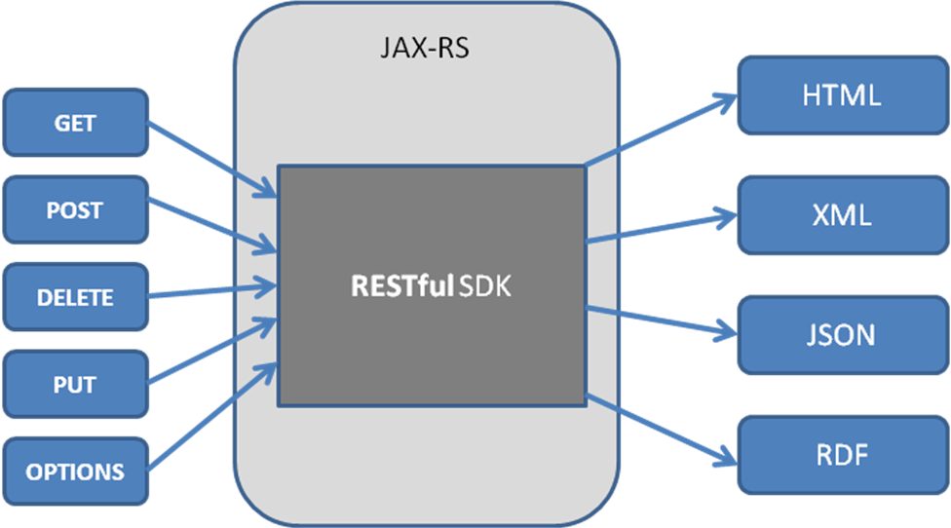

RESTful SDK will provide ability to process multiple formats of requests based on QBE, HQL, CQL and URI through GET, PUT, POST and DELETE methods. This approach would not require any dramatic changes in SDK. Given the flexible n-tier architecture of SDK, RESTful interface can easily replace existing custom Servlet implementation.

With JAX-RS, each resource is identified by URI. Client exchanges with the resource via HTTP requests and responses using fixed set of HTTP methods. Each resources can have one or more representations, thus SDK can support multiple representations like RDFa, JSON, XML. It also provides ways to discover REST services with HTTP method OPTIONS or through WADL.

A very important aspect of REST is hyperlinks, URIs, in representations that clients can use to transition the Web service to new application states. A client that is making a request to a RESTservice would construct URI including any path or query parameters. Parameters passed through the URI are used by the service to process the request.

Example: http://localhost:8080/example/Person/1
Or http://localhost:8080/example/Person?id-1

These requests would represent querying for Person with Id=1. It does let a client to specify a criteria like id<>1. SDK introduced a query parameter with format that would let a client to make request with one or more objects, criteria, associations and roles. Currently, SDK REST query parameter supports “=” operator only.

query=<target>&<criteria>[&rolename=<rolename>]

Given the limitation with criteria operator, with JAX-RS adoption, SDK can easily expand its ability to support querying by domain objects or through other standardized formats like SPARQL.

References
http://jsr311.java.net/nonav/releases/1.1/spec/spec.html

http://cxf.apache.org/docs/jax-rs-basics.html

http://www.vogella.de/articles/REST/article.html

http://wikis.sun.com/display/Jersey/Overview+of+JAX-RS+1.0+Features

http://jersey.java.net/nonav/documentation/latest/user-guide.html#getting-started

http://cxf.apache.org/docs/jaxrs-services-configuration.html#JAXRSServicesConfiguration-ConfiguringJAXRSservicesincontainerwithoutSpring

http://code.google.com/a/eclipselabs.org/p/restful-webservice-demo-project/

https://wiki.nci.nih.gov/display/caCORE/8.2+-+XML-JSON-HTTP+Interface+for+caCORE+SDK+4.4

